DEPARTMENT OF

# COMPUTER SCIENCE & ENGINEERING

## **“Experiment 4”**

1. **Aim:**

Program to interface the Arduino/Raspberry Pi with LED and blinking application.

1. **Objective:**

* Learn about interfacing.
* Learn about IoT programming.

1. **Components Required:**

You will need the following components –

* + 1 × Breadboard
  + 1 × Arduino Uno R3
  + 1 × LED
  + 1 × 330Ω Resistor
  + 2 × Jumper

1. **Procedure**:

LEDs are small, powerful lights that are used in many different applications. To start, we will work on blinking an LED, the Hello World of micro controllers. It is as simple as turning a light on and off. Establishing this important baseline will give you a solid foundation as we work towards experiments that are more complex.

Turn on LED programmatically via Pin 10

* + Step 1: Start a new sketch in the Arduino IDE. Start a new sketch in the Arduino IDE.
  + Step 2: Set the pinMode for Pin 10.
  + Step 3: Set Pin 10 HIGH.
  + Step 4: Compile the code.
  + Step 5: Upload the code to Arduino.

DEPARTMENT OF

# COMPUTER SCIENCE & ENGINEERING

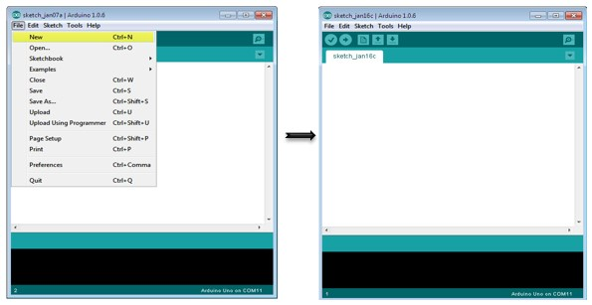

1. **Code:**

// the setup function runs once when you press reset or power the board

void setup() {

// initialize digital pin LED_BUILTIN as an output.

pinMode(2, OUTPUT);

}

// the loop function runs over and over again forever

void loop() {

digitalWrite(2, HIGH); // turn the LED on (HIGH is the voltage level)

delay(500); // wait for a second

digitalWrite(2, LOW); // turn the LED off by making the voltage LOW

delay(500); // wait for a second

}

1. **Output:**

DEPARTMENT OF

# COMPUTER SCIENCE & ENGINEERING

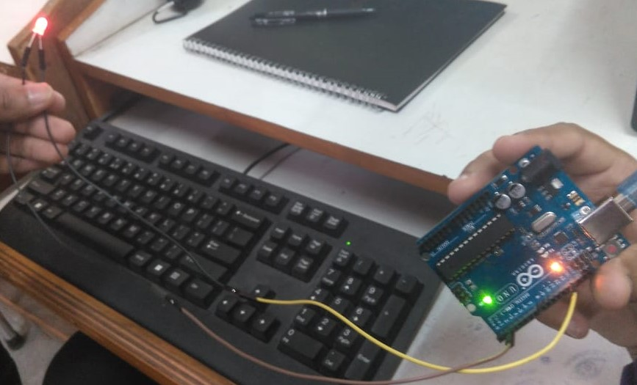

**Learning outcomes (What I have learnt):**

* Learnt about interfacing.
* Learnt about IoT programming.
* Learnt about Arduino IDE.